

Software Requirements Specification (SRS)

(SHEFAA)

Smart Healthcare Entry & Facility Automation Assistant

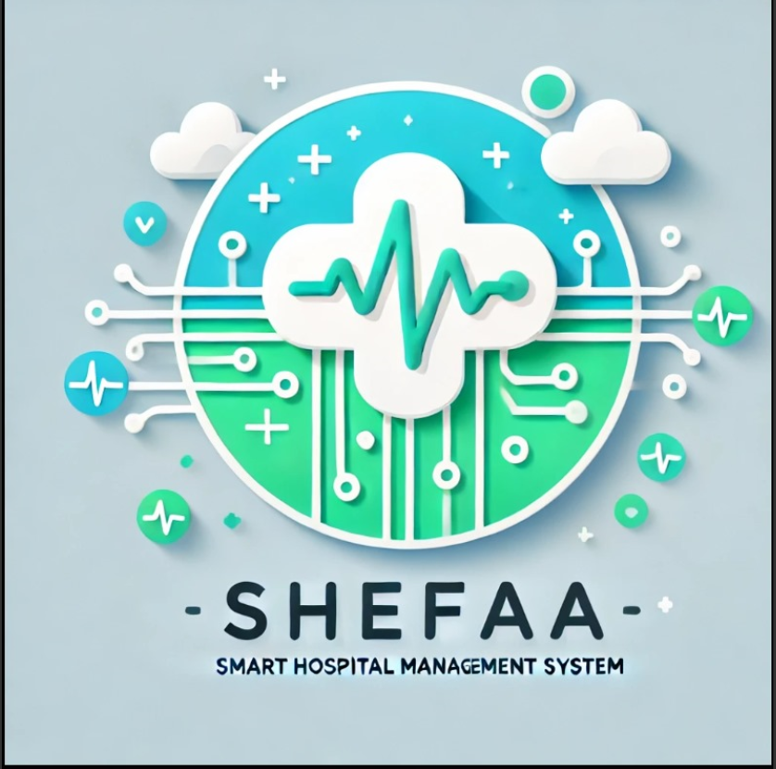

Team Members:

1-محمد ايمن فتحي عبد الغني

2-محمود صلاح عبد المعز السلكاوي

3-كريم احمد سعد أبو العزم

4-عمر امجد عبد العزيز

5-محمد خالد سعد

6-عمر هاني صابر

1. Preface

1.1 Document Purpose
This document outlines a detailed Software Requirements Specification (SRS) for the Hospital Management System (HMS). It is intended to serve as a guide for developers, testers, and stakeholders.

1.2 Target Users
- Customers (patients): we aim to confirm that the system satisfying their needs.

- Managers: As an administrator, who Aid in planning and scheduling development.

- System Engineers: Comprehend the system's structure and functionality.

- Stuff(Doctors): who will deal with patients.

- Testers: verification of the running system.

2. Introduction

2.1 Purpose

The Hospital Management System aims to automate the registration, appointment booking, and management of patient and doctor records within a hospital.

2.2 Scope

The system offers:
- Patient registration and management.
- Appointment scheduling with doctors. Secure storage and retrieval of patient and doctor information.
- Role-based access control for administrators, doctors, and patients.
- 2.3 Overview
The SRS includes:
- System Users
- User Requirements
- System Architecture
- Functional and Non-Functional Requirements
- System Models and Diagrams

3. Glossary
Term | Definition
SRS | Software Requirement Specification
HMS | Hospital Management System
Admin | The hospital administrator managing the system
Patient | A registered user seeking medical attention {customer }
Doctor | A registered healthcare provider
SHEFAA | Smart Healthcare Entry & Facility Automation Assistant {Project's name}

4. System Users
  - System Stakeholders:

- Admin of the system.
- Doctor.
- Patient.
- Hospital.

  - Users' Objectives
  - Admin: Maintain system security and data integrity.
  - Doctor: Access patient history, manage schedules and negotiate about them.
  - 3. Patient: Book and manage appointments.

5. User Requirements
  - System Functions

- User authentication and authorization.
- Patient registration and record management.
- Doctor management.
- Appointment scheduling system.

5.2 Constraints
- The system should only be managed via internet.
- Database should be password-protected.

6. System Architecture
The system follows a client-server model with a Desktop application interface for access. It includes:
- Front-end: Java GUI .
- Back-end: Java (for the application) & python (for the chatbot , that integrated in system).
- Database: SQL SERVER for database.

7. System Functional Requirements
- Specific patient ID.
- Patient record storage and retrieval.
- Doctor profile management.
- Appointment scheduling system.
- Creating a medical history for each patient

8. Interface Requirements

8.1 User Interfaces
- Login page.
- Patient registration page.
- Doctor login and managing profile.
- Patient managing profile page.
- Admin managing page.
- Appointment booking interface.
- Chatbot give medical advices
  - Hardware Interfaces
- Requires a PC with at least Core i3 processor , 4GB RAM and 1GB free space in storage

8.3 Software Interfaces
- Runs on Windows 10 or higher
- Uses SQL SERVER for database management.

8.4 Communication Interfaces
- HTTP protocol for CHATBOT access.
- Secure database connection with authentication.

9. Non-Functional Requirements
- Performance: Response time < 1s for database queries.
- Security: Only authorized users can access system components as:
- Patient only could sign up for the system as a new record in database without taking permissions from Admin.
- Admin only who can remove doctor from the database system.
- Availability: System should be available 24/7.

10. System Models and Diagrams
- Use Case Diagram: Illustrates interactions between users and the system.
- Activity Diagram: Illustrates behaviors of users with the system and database.

- Class Diagram: which describes the classes and function which in the system.
- Sequence Diagram: Shows the sequence of interactions for specific use cases.

11. System Evolution
Future updates may include:
- Developing chatbot to AI-based patient diagnostics.
- Mobile Application: Develop a mobile app for easier access to the system.

12. References
- "Hospital Management System: A Case Study of Bagamoyo District Hospital" - Academia.edu
https://www.academia.edu/39902772/HOSPITAL_MANAGEMENT_SYSTEM_A_CASE_STUDY_OF_BAGAMOYO_DISTRIC_HOSPITAL
- "Transforming Healthcare with Digital Innovation: Al Azhar Hospital Case Study" - Avicenna Health
https://avicenna-health.ai/case-studies

